

"Empowering Students. Equipping Educators. Elevating Excellence."
Julon K. Eatmon, Ed.D.
Founder & CEO

Executive Summary

The Eatmon Edge
The Eatmon Edge is an educational consulting and academic success company dedicated to helping students, educators, and school systems achieve measurable excellence.
Founded by Dr. Julon Eatmon, a veteran educator with more than two decades of experience in mathematics instruction, instructional leadership, curriculum development, testing coordination, and educational consulting. The Eatmon Edge was established to bridge the gap between academic potential and academic achievement.
The company specializes in
• ACT Preparation
• College Readiness
• Mathematics Tutoring
• School Improvement Consulting
• Teacher Professional Development
• Leadership Coaching
• Data Analysis
• Curriculum Development
Unlike traditional tutoring companies, The Eatmon Edge combines research-based instructional strategies with data-driven decision-making to create sustainable academic growth.



Motto:
Preparing Today.
Leading Tomorrow.

Founder Biography
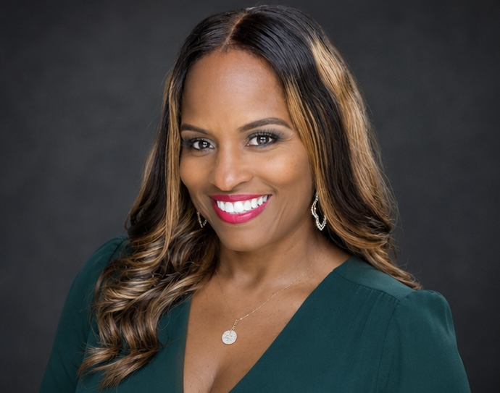

Dr. Julon K. Eatmon

Founder, The Eatmon Edge
Julon K. Eatmon is an accomplished educator and instructional leader whose career reflects a commitment to academic excellence, data-driven decision-making, and continuous school improvement. Throughout her career with Birmingham City Schools, she has served in multiple leadership capacities, with some of her most significant contributions occurring through her work as a Curriculum Coach and Testing Coordinator at Huffman High School.
As a Curriculum Coach, Eatmon has worked alongside teachers and school leaders to strengthen instructional practices, analyze student performance data, align instruction with academic standards, and develop strategies designed to increase student achievement. Her leadership has emphasized collaborative planning, formative assessment, meaningful feedback, and the intentional use of data to identify instructional needs and guide intervention. She has supported professional learning and collaborative planning across content areas, helping teachers translate accountability and assessment data into actionable classroom practices.
In her role as Testing Coordinator, Eatmon has overseen the planning and administration of standardized assessments, including coordinating testing schedules, managing testing materials, training and supervising test administrators and proctors, maintaining testing security and compliance, and collaborating with district-level personnel. Her responsibilities have extended beyond test administration to include the analysis and communication of assessment results so that student performance data can be used to identify areas of strength, address academic gaps, and inform schoolwide instructional decisions.
Eatmon's work has been closely connected to Huffman High School's broader accountability and improvement efforts. Through collaborative planning, data analysis, instructional support, assessment coordination, and a schoolwide focus on student growth. She has assisted Huffman High School in achieving a six-point increase on its state report card over the past two years. Her approach to leadership reflects the belief that school improvement is not simply about numbers—it is about creating systems that help teachers improve their practice while providing students with greater opportunities to succeed.
Her leadership also includes using ACT performance and proficiency data to help identify students requiring targeted support, guide PLC conversations, develop instructional responses, and monitor student growth. Recent accountability work at Huffman has incorporated ACT Composite scores, College and Career Readiness benchmarks, proficiency levels, and content-specific performance data as part of the school's continuous improvement process.
With experience spanning instruction, curriculum, assessment, testing, data analysis, teacher support, and school improvement, Eatmon has developed a leadership philosophy centered on collaboration, accountability, and informed decision-making. She is passionate about helping educators understand not only what the data says, but what to do next because of it. Her work reflects a continued commitment to building instructional capacity, strengthening educational systems, and creating measurable outcomes for students and schools.
As the founder of The Eatmon Edge, Julon K. Eatmon brings these experiences together to support students, educators, schools, and school systems in achieving higher levels of performance. The company's philosophy reflects the principles that have guided her educational career: preparation builds confidence, data should inform instruction, relationships matter, growth is possible, and excellence must be intentional.

Her professional mission is clear:
Equip educators. Empower students. Strengthen schools. Create opportunities for excellence.

Mission Statement



Vision Statement



Core Values



Brand Story:
Why does The Eatmon Edge exist?

Every student deserves an opportunity to succeed—not because of where they come from, but because of the potential they possess. After spending more than two decades in education, I witnessed firsthand how the right instruction, encouragement, and strategy could transform a student's confidence and academic future. I also observed the challenges educators face in meeting the diverse needs of learners while balancing increasing accountability demands. These experiences inspired me to establish The Eatmon Edge: a company dedicated to equipping students with the tools to excel, empowering educators with practical solutions, and partnering with schools to create lasting educational impact.

Business Philosophy

We Believe...


- Every student can learn.
- Every educator can improve.
- Every school can grow.
- Preparation creates confidence.
- Data should drive instruction.
- Relationships matter.
- Excellence is intentional.

Why The Eatmon Edge?



We don't simply prepare students for the ACT.
- We prepare them for college.
- For careers.
- For confidence.
- For life

What Makes the Eatmon Edge Different?
Unlike many ACT tutoring companies, The Eatmon Edge is led by an experienced educator and instructional leader with expertise in curriculum, assessment, school improvement, and educational leadership. Our approach combines classroom experience with research-based instructional practices and data analysis to support students, educators, and schools.


"Our personalized, research-based approach equips students with the strategies and confidence to maximize their ACT performance."

Academic Programs & Curriculum


ACT Academy

Bronze Program
(4 Weeks)
Diagnostic
Weekly Homework
Parent Report
Practice Test
Certificate

Silver Program
(8 Weeks)
Diagnostic
Workbook
Weekly Tutoring
Parent Conferences
ACT Dashboard

Gold Program
(12 Weeks)
Unlimited Support
Essay Review
College Planning
Scholarship Search
Parent Portal

Math Academy
Algebra I
Geometry
Algebra II
Precalculus
ACT Math
College Algebra

Summer Academy
June
July
STEM Camps
Bridge Programs

Curriculum Maps
Week-by-week
Lesson Plans
PowerPoints
Homework
Assessments
Exit Tickets
Data Trackers

Parent Communication
Weekly emails
Progress reports
Celebration letters
Intervention letters

Student Incentives
Edge Scholars
Student of the Month
ACT Hall of Fame
Scholarship Wall

School Consulting Division

Stronger Systems. Stronger Instruction. Stronger Outcomes.

1. Division Overview
The Eatmon Edge School Consulting Division partners with schools and school systems to transform educational data into meaningful action. Our consulting model combines instructional leadership, curriculum support, assessment expertise, professional learning, and strategic planning to help schools identify challenges, strengthen instructional systems, and improve student outcomes.
Rather than offering one-size-fits-all solutions, The Eatmon Edge works collaboratively with school leaders and educators to identify the school's specific needs, establish measurable goals, implement targeted strategies, and monitor progress toward sustainable improvement.
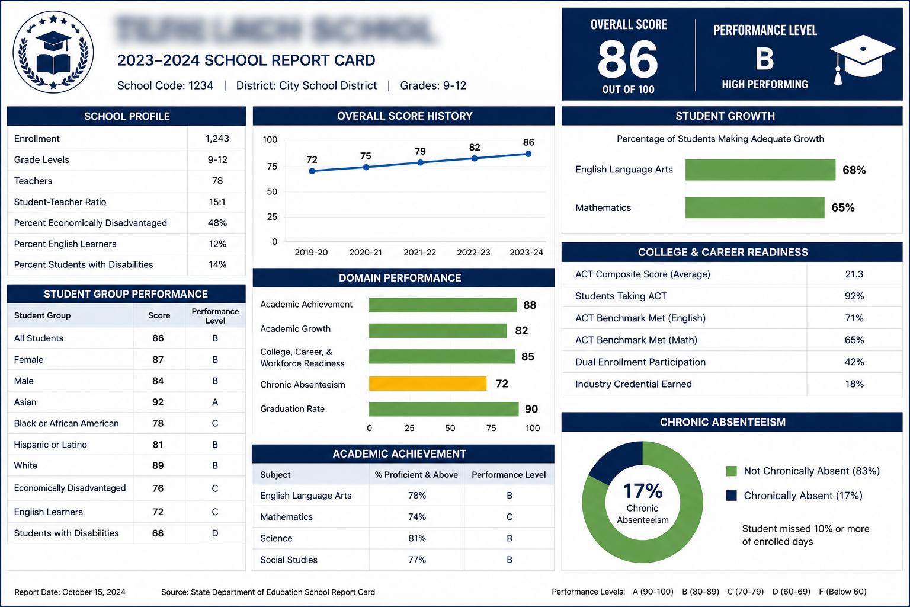
We don't come into schools simply to tell educators what needs to change. We help them build the systems, knowledge, and capacity to make the change happen.

2. The E.D.G.E. Consulting Model

E — EVALUATE
Where are we now?
Review:
- Accountability data
- ACT performance
- State assessment results
- Classroom assessment data
- Curriculum implementation
- Instructional practices
- Attendance
- Discipline
- Graduation/CCR data
- Teacher and student surveys
- Existing improvement plans
Deliverable: The Eatmon Edge School Performance Diagnostic

D — DESIGN
Where do we need to go?
Together with school leadership, establish:
- Priority areas
- SMART goals
- Success indicators
- Instructional priorities
- Professional learning needs
- Intervention strategies
- Monitoring systems
- Leadership responsibilities
Deliverable: Customized School Improvement Action Plan

G — GROW
How will we get there?
Professional development, instructional coaching, PLC facilitation, curriculum support, assessment development, leadership coaching, and targeted student interventions.
Deliverable: Implementation & Coaching Plan

E — EXCEL
Did it work—and how do we sustain it?
Analyze:
Baseline → Interim → Outcome
Then determine what should be continued, modified, expanded or discontinued.
Deliverable: Impact & Sustainability Report

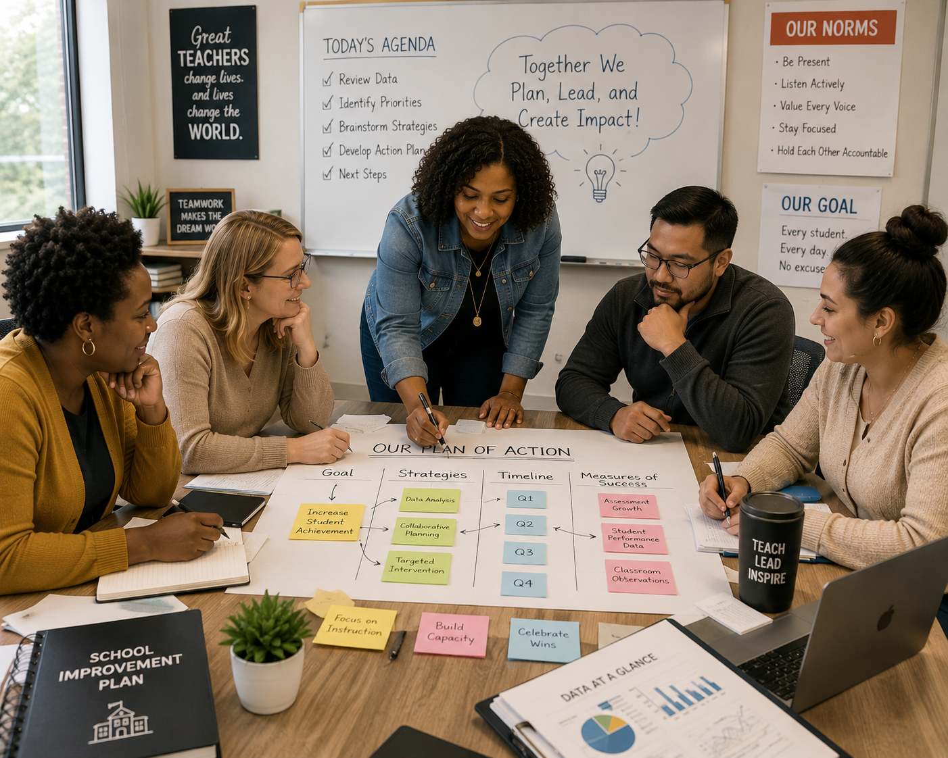

3. School Performance Diagnostic
Before recommending anything, The Eatmon Edge conducts a needs assessment.
For example:

Academic Achievement
Indicator | Current | Goal | Gap
ACT Math Proficiency | 12% | 20% | 8 pts
ACT English Proficiency | 18% | 25% | 7 pts
CCR Rate | 72% | 85% | 13pts
Graduation Rate | 89% | 93% | 4 pts

4. ACT & College Readiness Consulting

The Eatmon Edge ACT School Improvement Program
The consulting process would include:
Phase I — ACT Data Audit
Analyze performance by subject, standard/domain, student, subgroups and course.
Phase II — Curriculum Alignment
Determine where ACT-tested skills occur within Algebra I, Geometry, Algebra II, English, science and other relevant courses.
Phase III — Teacher Capacity
Train teachers to integrate ACT-style reasoning into everyday instruction rather than treating ACT preparation as an isolated event.
Phase IV — Student Intervention
Identify students by readiness level and provide targeted support.

For example:
Intensive → Developing → Approaching Benchmark → Benchmark → Advanced
Each group receives a different intervention strategy.
Phase V — Progress Monitoring
Diagnostic → Instruction → Mini-Assessment → Data Review → Intervention → Reassessment

5. Data-Driven Instruction Consulting
Instead of just ‘giving’ teachers spreadsheets and saying, "Look at your data," you teach them how to answer four questions:
- What happened? 2. Why did it happen? 3. What are we going to do about it?
4. How will we know if it worked?

Sample Data Meeting Protocol
Teachers would identify:
Celebrate: Where did students demonstrate success?
Investigate: Where are the largest gaps?
Analyze: Which standards contributed to those gaps?
Respond: What instructional adjustments are needed?
Monitor: What evidence will show whether the adjustment worked?

6. Curriculum & Instruction Audit
Curriculum guides → Standards → Lesson plans → Classroom instruction → Assessments → Student work → Results
The final report would rate areas such as:
Strong Practice | Developing Practice | Priority Area | Immediate Action Needed
Then provide recommendations.

7. PLC Transformation
Rather than PLCs becoming meetings where teachers discuss announcements, The Eatmon Edge could help schools establish instructional PLCs.
Every PLC revolves around:
- What should students know?
- How will we know whether they learned it?
- What will we do when they don't?
- What will we do when they have it?

Sample 60-Minute PLC
10 minutes: Celebrations and progress
15 minutes: Student data
15 minutes: Student work
10 minutes: Instructional response
5 minutes: Intervention/enrichment
5 minutes: Commitments before next meeting


8. Instructional Coaching

PLAN → OBSERVE → REFLECT → RESPOND
The consultant and teacher establish a focus area.
Then:
Pre-conference → Classroom observation → Evidence collection → Reflection → Feedback → Action step → Follow-up
Coaching is developmental, not punitive.
The purpose is teacher capacity—not catching teachers doing something wrong.

9. Leadership Coaching
The Eatmon Edge expands beyond teacher support.
Coaching is also offered for:
- Principals
- Assistant principals
- Curriculum coaches
- Department chairs
- Testing coordinators
- Instructional leadership teams
Topics include instructional leadership, difficult conversations, accountability data, observation and feedback, school improvement planning, PLC leadership, and building teacher capacity.

10. Assessment Systems Consulting

Testing Coordinator Professional Development

The Eatmon Edge Assessment Leadership Academy
From Testing Coordinator to Assessment Leader
Plan. Prepare. Protect. Perform. Analyze.

Testing Coordinator 101: Building the Foundation
This applies to testing coordinators, assistant principals, counselors, or administrators who are taking on testing responsibilities.
Participants would learn about the overall role of a testing coordinator, developing an annual assessment calendar, working backward from testing dates, identifying key personnel, communicating with administrators and staff, organizing documentation, anticipating testing needs, and establishing systems before testing season begins.

Activity: Build Your Testing Year
Participants receive a sample school calendar and assessment schedule and create a 12-month testing coordinator roadmap.
Takeaway: The Eatmon Edge Testing Coordinator Annual Planner.

Building the Master Testing Plan
Participants work through:
Students → Rooms → Staff → Time → Technology → Materials → Accommodations → Makeups
They learn how to create room assignments, testing rosters, administrator assignments, relief plans, testing schedules, material distribution systems, and contingency plans.

Simulation
Give teams a fictional high school with:
- 750 students
- 42 testing rooms
- Students requiring accommodations
- Limited computer labs
- Absent teachers
- A shortened school day
Their challenge is to build the testing plan.

Testing Security: Protecting the Integrity of Assessment
Topics could include test security expectations, secure materials, chain of custody, prohibited practices, room security, electronic devices, documentation, irregularities, and appropriate escalation procedures.
Because specific requirements differ by assessment and can change, your training materials should distinguish between general best practices and the current official requirements for the particular assessment being administered.

Case Study Activity
A test administrator realizes after testing begins that students were given the wrong test materials. What happens next?
Teams determine:
STOP → DOCUMENT → SECURE → REPORT → FOLLOW OFFICIAL PROCEDURES
You could present several realistic scenarios and have participants determine the appropriate response.

Training the Test Administrator
This is important because a testing coordinator cannot personally supervise every room.
The coordinator's success depends heavily on how effectively the testing staff has been trained.
The workshop could address how to conduct effective pre-administration training, communicate responsibilities clearly, verify staff understanding, prepare room supervisors, train proctors, explain prohibited practices, establish communication procedures and document required training.

Activity: Train the Trainer
Participants receive a poorly designed test-administrator training presentation and must identify what is missing.
Then they develop a stronger 30-minute staff training plan.

Accommodations & Accessibility
Topics might include organizing approved accommodations, developing accommodation rosters, scheduling students appropriately, identifying testing spaces, preparing staff, maintaining confidentiality, coordinating with special education/504/EL personnel, and verifying that the correct testing conditions are available.
A central message:
Accommodation isn't helpful if the testing team doesn't have a system to deliver it correctly.

Activity
Participants receive fictional student profiles and build an Accommodation Testing Matrix showing students, assigned rooms, approved support, administrator, and schedule.
- Testing-Day Command Center
Participants learn how to establish a centralized testing command structure.

Before Students Arrive
Staff check-in
Materials check-out
Room verification
Technology verification
Student rosters
Communication systems

During Testing
Attendance monitoring
Late arrivals
Room support
Irregularity response
Staff relief
Material tracking

After Testing
Student dismissal
Material return
Inventory
Documentation
Secure storage
Makeup identification

Simulation: Testing Day Goes Wrong
Give participants situations every few minutes:
7:45 — Two test administrators are absent.
8:05 — Twenty students report to the wrong location.
8:20 — A testing device will not connect.
9:10 — A student becomes ill.
10:15 — Testing materials cannot immediately be accounted for.
Teams must manage the situation while protecting the integrity of the administration.
This could become a signature Eatmon Edge training activity.

Testing Irregularities & Crisis Response
This session teaches coordinators to respond systematically rather than react emotionally.
Potential scenarios could involve technology failure, illness, fire alarm, weather emergency, student misconduct, unauthorized electronic devices, staff errors, timing concerns, incorrect materials or other disruptions.
Participants practice:
Recognize → Stabilize → Secure → Document → Report → Follow Guidance

ACT Administration Leadership
Because ACT/college readiness can be a flagship area for The Eatmon Edge, this deserves specialized professional learning.
Rather than replacing official ACT training, this session would focus on the school-level leadership and organizational systems surrounding ACT administration.
For example:
Preparing students and families, building the testing-day structure, coordinating staff, organizing rooms, planning accommodations, developing communications, creating contingency plans and transitioning from administration to results analysis.
Then connect testing to instruction:
ACT Administration → Results → Data Analysis → Instructional Response → Intervention → Progress Monitoring

From Testing Data to Instructional Decisions
Many testing programs end here:
"Scores are back."
The Eatmon Edge asks:
"Now what?"
Participants learn how to analyze results by student, content area, skill/domain, course, teacher/team, subgroup, and performance level.
Then move from:
DATA → QUESTION → FINDING → RESPONSE → MONITORING
For example:
Finding: Students demonstrate weakness in a particular mathematics skill.
Question: Is the issue of curriculum exposure, conceptual understanding, instructional practice, or assessment of familiarity?
Response: Determine the appropriate instructional intervention.
Monitoring: Establish evidence that will tell the team whether the intervention worked.
This ties directly into your curriculum-coaching expertise.

J Building a Schoolwide Assessment Calendar
Schools can unintentionally over-assess students.
This workshop asks teams to map every assessment given throughout the year.
They categorize each as:
Diagnostic | Formative | Interim | Benchmark | Summative | State/Required

Then ask:
Why are we administering this assessment?
Who uses the results?
What instructional decision does it inform?
Are we collecting data that nobody actually uses?
The goal becomes creating a coherent schoolwide assessment system, not simply adding more tests.

K. Testing Communication That Prevents Confusion
Testing coordination is also communication management.
Participants could develop communication systems for:
Administrators — what leadership needs to know.
Teachers — schedules, responsibilities, and expectations.
Students — preparation and testing-day expectations.
Parents — dates, purpose, attendance and preparation.
Support Staff — operational responsibilities.

Activity
Participants create a complete communication package:
Parent letter + teacher memo + student announcement + administrator briefing + testing-day quick reference.

L. Testing Coordinator Binder Boot Camp
Participants literally build their testing coordinator binder during the session.
Possible tabs:
- Assessment Calendar
- Official Guidance
- Contacts
- Student Rosters
- Accommodations
- Staff Assignments
- Room Assignments
- Training
- Communications
- Materials
- Security
- Irregularities
- Makeup Testing
- Data & Reports
- After-Action Review

M. Leading Without Authority
Testing coordinators frequently have to coordinate with adults who do not report directly to them.
Topics:
Communicating expectations, gaining staff buy-in, managing resistance, delegating effectively, addressing noncompliance professionally, working with administrators and conducting difficult conversations.
A scenario might be:
A veteran teacher tells the testing coordinator, "I've been doing this for 20 years. I don't need another training."
Participants practice appropriate leadership responses.
This turns the academy into leadership development, not merely test administration.

N. After the Test: Conducting an After-Action Review
Testing shouldn't end when materials are returned.
Have the team evaluate:

What worked?

What didn't?

What surprised us?

What created unnecessary stress?

What should we change next time?

What systems need to be strengthened?
The coordinator then creates a Testing Administration Improvement Report.
That creates institutional knowledge, so the school doesn't repeat the same problems every year.

O. Assessment Leadership for Administrators
A separate 2–3-hour version specifically for principals and assistant principals will be created.
Administrators don't necessarily need every operational detail.
They need to understand:
What should I expect from my testing coordinator?
What does my testing coordinator need from me?
What risks should I be aware of?
How do I build a culture that takes assessment seriously without creating unhealthy pressure?
How should assessment data influence school improvement?
This lets you train the leadership team and testing coordinator together.

P. The Full Eatmon Edge Testing Coordinator Academy
You could package the professional development into an 8-module certification-style academy:
 | Professional Learning
1 | The Role of the Assessment Leader
2 | Master Testing Plan & Logistics
3 | Security, Ethics & Compliance
4 | Accommodations & Accessibility
5 | Training Test Administrators
6 | Testing-Day Operations & Crisis Response
7 | Data Analysis & Instructional Response
8 | Continuous Improvement & Leadership
At the conclusion, participants complete a capstone:

THE TESTING MASTER PLAN
Each participant develops a complete assessment of operations plan for their own school.
They would present:
Calendar + Staffing + Rooms + Accommodations + Communications + Security + Contingency Plan + Data Plan + Continuous Improvement Plan
After completion, they could receive a formal Eatmon Edge Assessment Leadership Academy Certificate of Completion. I would use "certificate of completion" rather than imply a state-recognized professional certification unless you later establish the necessary approval/accreditation structure.
What Makes This Academy Different?
The program will center around three levels of testing leadership:

LEVEL 1 — ADMINISTER
Can we administer the assessment correctly?
Logistics, procedures, staffing, security, and accommodations.

LEVEL 2 — ANALYZE
Can we understand what the results tell us?
Performance, trends, gaps, and priorities.

LEVEL 3 — ACT
Can we turn those findings into better instruction?
Curriculum, intervention, professional learning, PLCs, and progress monitoring.
That gives The Eatmon Edge a powerful message:
Testing coordination shouldn't end with successful administration. Great assessment of leadership turns testing into information—and information into action.



11. Professional Learning: From School Need to School Improvement
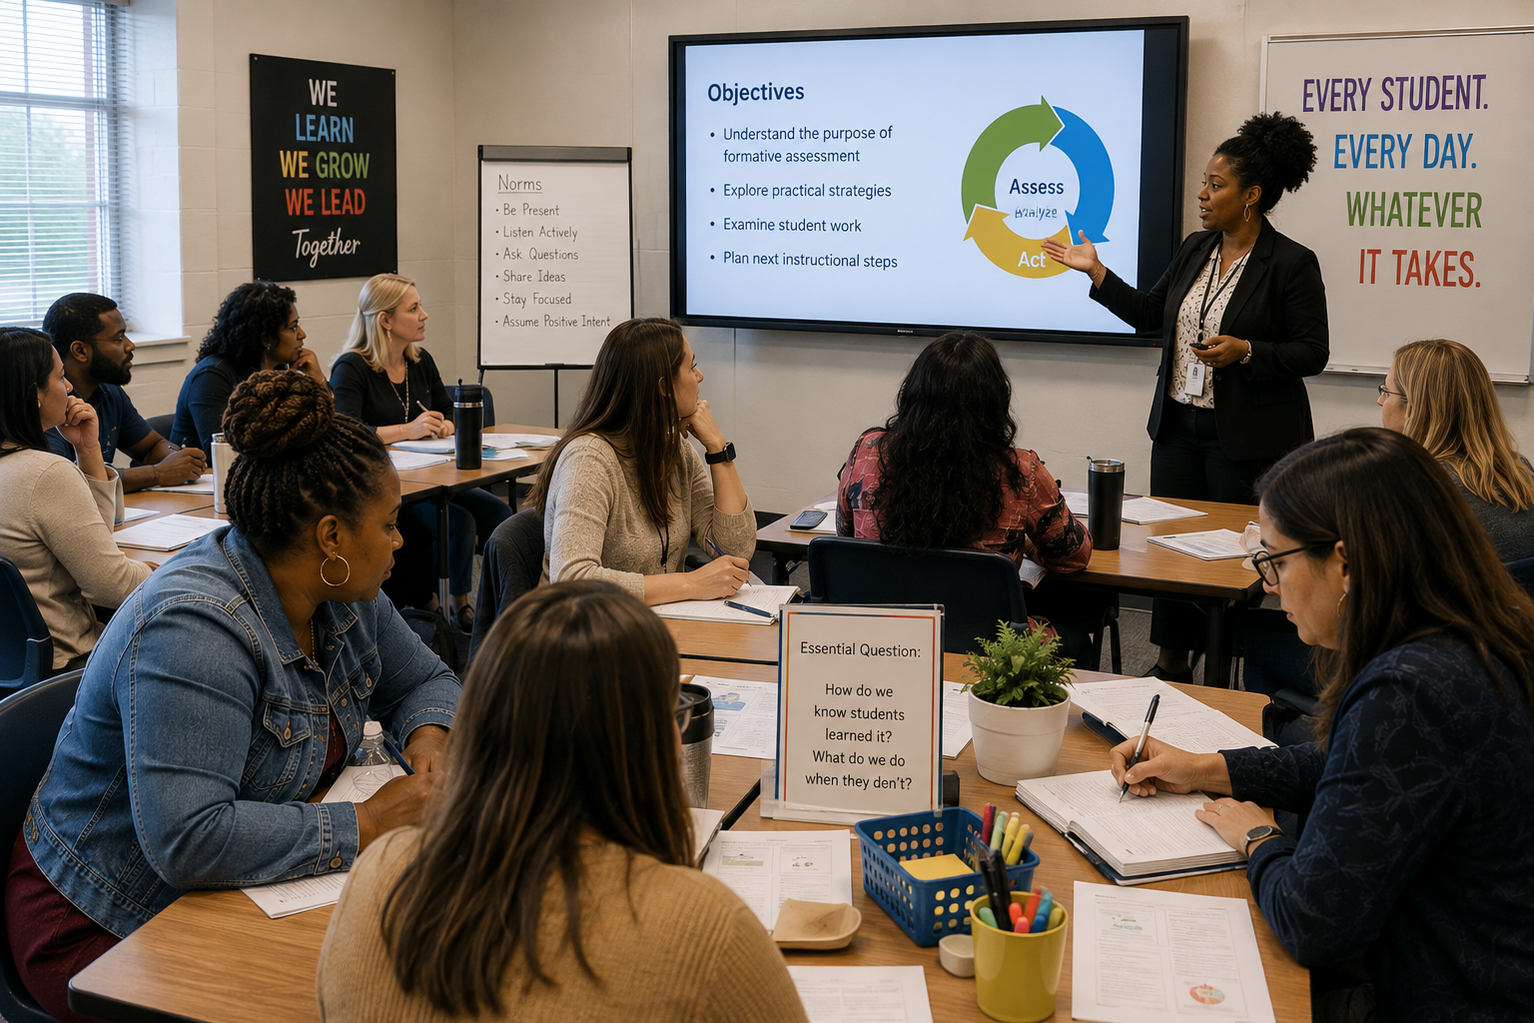

Example 1 — From Data to Decisions
School Need:
A high school gives several benchmark assessments throughout the year, but teachers primarily review overall percentages. PLC conversations often sound like, “My students didn't do well on this standard,” without determining why or what should happen next.
The Eatmon Edge Response:
Provide From Data to Decisions: Turning Information Into Instructional Action.
During the PD: Teachers receive sample data showing:
Learning Standard | Students Assessed | Students  Proficient | Proficiency Rate
Standard 1 | 120 | 91 | 76%
Standard 2 | 120 | 47 | 39%
Standard 3 | 120 | 78 | 65%
Standard 4 | 120 | 36 | 30%
Instead of simply identifying Standards 2 and 4 as low, teams investigate:
What skills were required?
What errors did students make?
Was the standard taught?
How was it taught?
Was the assessment aligned with instruction?
Which students struggled?
They then develop an instructional response.
Action Plan Example:
Priority: Standard 4
Finding: Students can perform the basic skill but struggle when it appears in a multi-step application problem.
Instructional Response: Increase opportunities for application and problem solving.
Reassessment: 5-question common formative assessment in two weeks.
Success Indicator: At least 70% demonstrate proficiency.
Follow-Up: The Eatmon Edge returns to the next PLC to examine the new results.

Example 2 — ACT Across the Curriculum
School Need:
ACT scores are low, and ACT preparation primarily occurs during the weeks immediately before testing.
The Eatmon Edge Response:
Implement ACT Across the Curriculum as a schoolwide professional-learning initiative.
During the PD: Departments identify ACT-related thinking already present in their courses.
For example:
Math: interpreting graphs, modeling, multi-step reasoning, and problem solving.
English: grammar, sentence structure, organization and revision.
Science: interpreting tables, graphs, experiments, and competing explanations.
Social Studies: Analyzing complex texts, evidence, and arguments.
Teachers then bring an upcoming lesson and answer:
Where can I naturally strengthen college-readiness thinking without turning my class into an ACT-prep course?
Example Teacher Plan:
Current activity: Students read an informational passage and answer comprehension questions.
Revised activity: Students identify the author's claim, locate supporting evidence, distinguish relevant from irrelevant information, and justify their answer using textual evidence.
Follow-Up: PLCs review student performance on embedded ACT-style questions throughout the semester.

Example 3 — Building Effective PLCs
School Need:
PLC meetings happen every week, but much of the time is spent discussing announcements, student behavior, upcoming events, and administrative tasks.
The Eatmon Edge Response:
Provide a Building Effective PLCs institute followed by PLC coaching.
Before:
"What do we need to cover this week?"
After:
"What evidence do we have that students learned what we taught?"
A sample PLC agenda becomes:
5 minutes — Celebrate
What improved?
10 minutes — Standard
What were students expected to learn?
15 minutes — Evidence
What does the assessment/student work show?
15 minutes — Analysis
Who learned it? Who didn't? Why?
15 minutes — Response
Re-teach? Intervention? Enrichment?
10 minutes — Commitment
Who will do what before the next PLC?
Consulting Follow-Up: The Eatmon Edge observes PLCs and provides feedback to teacher leaders and administrators.

Example 4 — Formative Assessment That Changes Instruction
School Need:
Teachers give exit tickets, but the results are often collected, graded, and returned without affecting the next day's instruction.
The Eatmon Edge Response:
Provide Formative Assessment That Changes Instruction.
During the PD: Teachers practice sorting sample student responses into four groups:
Group A — Mastered
Ready for enrichment.
Group B — Mostly Understands
Needs clarification.
Group C — Misconception
Needs targeted reteaching.
Group D — Significant Gap
Needs intensive support.
Then teachers must answer:
What will tomorrow's lesson look like because of today's results?
That becomes the expectation for formative assessment throughout the school.

Example 5 — Authentic Feedback
School Need:
Walkthroughs reveal comments on student work such as:
"Good job!"
"Try again."
"Incorrect."
"See me."
Students know whether something is wrong but frequently don't know how to improve it.
The Eatmon Edge Response:
Provide Authentic Feedback: Feedback That Moves Learning Forward.
Teachers transform ineffective feedback.
Before:
"Wrong. Check #7."

After:
"You selected the correct operation but look again at how you distributed the negative sign. Correct that step and solve it again."
Teachers then bring actual assignments and practice writing feedback answering:
Where is the student now?
Where should the student be?
What should the student do next?
Follow-Up Evidence: Administrators and coaches look for actionable feedback during walkthroughs and student-work reviews.

Example 6 — Differentiation Teachers Can Actually Implement
School Need:
Teachers report that student readiness levels vary dramatically and believe differentiation means creating several completely different lesson plans.
The Eatmon Edge Response:
Provide Differentiation Teachers Can Actually Implement.
Teachers receive one lesson and three fictional students:
Jordan: Missing prerequisite skills.
Taylor: Approaching grade-level proficiency.
Morgan: Already demonstrates mastery.
Teachers maintain the same learning target while changing appropriate support.
For example:
Jordan: Scaffold + prerequisite review + guided example.
Taylor: Grade-level task + strategic questioning.
Morgan: Extension/application problem requiring deeper reasoning.
The message becomes:
Different support does not mean different expectations.

Example 7 — Using Student Work to Improve Instruction
School Need:
Teachers discuss assessment percentages but rarely bring actual student work into collaborative planning.
The Eatmon Edge Response:
Implement a Student Work Analysis Protocol.
Teachers place three anonymous student responses on the table:
Student A — Mastery
Student B — Partial Understanding
Student C — Significant Misconception
Instead of immediately grading them, teachers answer:
What does this student understand?
What evidence supports that conclusion?
Where does the thinking break down?
What might have caused the misconception?
What should the teacher do next?
The team then identifies patterns across classrooms.
This is powerful because the conversation shifts from:
"Only 42% passed."
to:
"Students consistently understand the first step but cannot transfer the concept to an unfamiliar situation."
Now the team has something instructionally actionable.

Example 8 — Building a Culture of Academic Excellence
School Need:
Leadership notices inconsistencies across classrooms. Some classrooms demonstrate high expectations, strong student engagement, and rigorous instruction, while expectations are significantly lower in others.
The Eatmon Edge Response:
Facilitate Building a Culture of Academic Excellence with the entire faculty.
Staff complete a confidential culture audit.
Sample statements:
We believe every student can demonstrate meaningful academic growth.
Students are expected to explain their thinking.
Our interventions respond to evidence rather than assumptions.
Teachers collectively take responsibility for student success.
Academic growth is intentionally recognized and celebrated.
Participants rate each:
Strongly Agree | Agree | Unsure | Disagree | Strongly Disagree
The Eatmon Edge aggregates the results and helps leadership identify strengths, inconsistencies and priority areas.
The faculty then establishes 3–5 schoolwide commitments, such as:
1. Every student will experience rigorous grade-appropriate instruction.
2. Every PLC will use evidence of student learning.
3. Formative assessment will result in an instructional response.
4. Students will receive actionable feedback.
5. Growth and achievement will both be celebrated

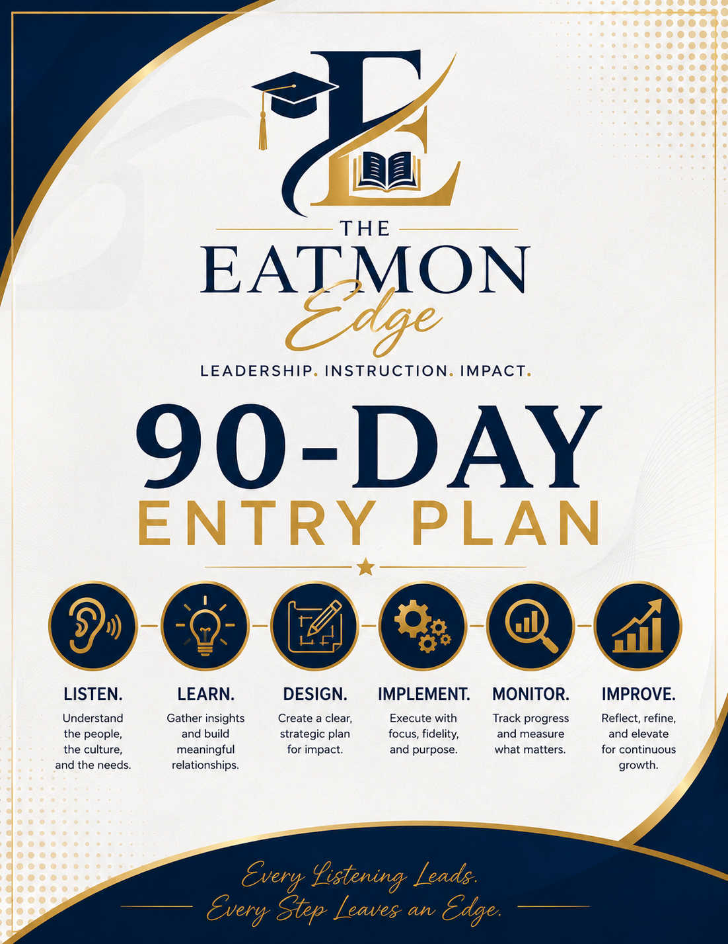

12. The Eatmon Edge 90-Day Entry Plan

Listen. Learn. Design. Implement. Monitor. Improve.

Days 1–30 — LISTEN & LEARN

Understand Before Attempting to Improve
Primary Goal: Develop an accurate picture of the school's strengths, challenges, systems, culture, instructional practices, and student-performance needs.

1. Meet With Leadership
Example: The Eatmon Edge conducts an initial 60–90-minute meeting with the principal and leadership team.
Possible questions:
- What are your school's three greatest strengths?
- What keeps you awake at night academically?
- Which accountability indicators concern you most?
- Where have previous improvement efforts succeeded?
- Where have they stalled?
- What do teachers need?
- What do students need?
- What would success look like 12 months from now?
Deliverable:
Leadership Needs & Priorities Summary
For example:
Leadership identified mathematics proficiency, inconsistent PLC implementation, and chronic absenteeism as the school's three highest priorities.

2. Analyze Data
The Eatmon Edge conducts a School Performance Data Audit.
Instead of only reviewing the overall report-card score, examine multiple indicators.

Example
Indicator | Current | Previous | Trend | Priority
Academic Achievement | 42 | 38 | ↑ | High
Academic Growth | 91 | 87 | ↑ | Maintain
CCR | 78% | 72% | ↑ | Moderate
Graduation | 92% | 90% | ↑ | Maintain
Chronic Absenteeism | 24% | 19% | ↓ | High
ACT Math Benchmark | 11% | 9% | ↑ | High
The conversation becomes:
Growth is strong, but proficiency remains low. Why are students growing without enough students reaching proficiency?

3. Survey Staff
Teachers often see problems leadership cannot see from aggregate data.

Sample Survey Statements
Teachers rate:
Strongly Agree → Strongly Disagree
Our curriculum clearly identifies priority standards.
PLC meetings improve my instruction.
Assessment results are used to determine instructional next steps.
I receive useful instructional feedback.
Students receive timely intervention when they struggle.
Professional development addresses problems I actually experience in my classroom.
Also include open-response questions:
What is working well?
What prevents students from being more successful?
What support would help you become more effective?

Example Finding
Perhaps:
68% of teachers say they regularly review assessment data.
But only:
31% say the data consistently changes what they teach next.
That's an important distinction.
Deliverable:
Staff Voice & Needs Report

4. Review Curriculum
The Eatmon Edge examines whether the:
Written Curriculum → Taught Curriculum → Assessed Curriculum
are aligned.

Example
Suppose Algebra II teachers are expected to teach a priority standard during Quarter 1.
You discover:
Curriculum Guide: Quarter 1
Teacher A: Quarter 1
Teacher B: Quarter 2
Teacher C: Not yet scheduled
Benchmark Assessment: Quarter 1
Now you have identified a system problem, not simply a student-performance problem.
Deliverable:
Curriculum Alignment Findings

5. Observe Instruction
These should initially be non-evaluative learning walks, not teacher evaluations.
Look for schoolwide patterns such as:
Learning targets
Student engagement
Cognitive demand
Questioning
Checks for understanding
Student discourse
Differentiation
Feedback
Technology use
Alignment to standards

Example Finding
After 25 classroom visits:
Learning targets were visible in 84% of classrooms, but students were able to explain what they were learning and why in only 36%.
That gives the school something much more meaningful to work on than simply:
"Teachers need to post objectives."
Deliverable:
Instructional Trends Snapshot

6. Identify Strengths
This part is extremely important.
The Eatmon Edge should never produce a report containing only deficiencies.
Suppose you identify:
Strong teacher-student relationships
High academic growth
Effective English PLC
Strong administrative visibility
Successful freshman intervention program
High teacher commitment
The question becomes:
How can we leverage what's already working?

End of Day 30
The school receives an:

EATMON EDGE SCHOOL DIAGNOSTIC REPORT
Containing:
Strengths
Priority Challenges
Data Findings
Instructional Findings
Staff Perceptions
Curriculum Findings
Recommended Priorities
Importantly, these are findings—not yet a massive list of initiatives.

Days 31–60 — DESIGN & IMPLEMENT

Turn Findings into Focused Action
Now you move from:
What is happening?
to:
What are we going to do about it?

1. Establish Priorities
A major mistake would be trying to fix everything identified during the first 30 days.
Instead, select 2–3 high-leverage priorities.

Example
After the diagnostic:

PRIORITY 1
Increase mathematics proficiency.

PRIORITY 2
Strengthen PLC effectiveness.

PRIORITY 3
Improve formative assessment and instructional response.
Notice that these priorities are connected.
Better formative assessment supports better PLC conversations, which supports mathematics improvement.

2. Develop the Action Plan
Each priority receives a measurable goal.

Example
Priority: Mathematics Achievement
Baseline: 34% proficiency on common assessment.
90-Day Target: 50%.
Strategy: Common formative assessments + targeted reteaching + PLC data cycles.
Responsible: Math department chair, teachers, instructional coach.
Evidence: Common assessment results and student work.
Monitoring: Every two weeks.
Now the improvement plan answers:
WHAT?
WHO?
WHEN?
HOW?
HOW WILL WE KNOW?

3. Launch Professional Learning
Professional development is selected because of the diagnostic—not because The Eatmon Edge simply wants to deliver a workshop.

Example
The diagnostic reveals:
Teachers collect assessment data but struggle to determine appropriate instructional responses.
Therefore:

PD #1
From Data to Decisions
Two weeks later:

PD #2
Formative Assessment That Changes Instruction
Then PLCs apply those practices.
That's job-embedded professional learning.

4. Begin Coaching
Suppose formative assessment becomes a school priority.
The coaching cycle could be:

PLAN
Teacher and coach select a formative assessment strategy.

IMPLEMENT
The teacher uses it during instruction.

OBSERVE
Coach collects evidence.

REFLECT
The teacher and Coach analyzed what happened.

RESPOND
They determine the next instructional adjustment.
The purpose isn't:
"Did the teacher do what we told them?"
It is:
"Did the strategy provide useful evidence about student learning, and what did the teacher do with that evidence?"

5. Establish PLC Expectations
Instead of telling teachers:
"Your PLCs need to be better."
Provide structure.

Sample Weekly PLC
5 min — Celebrations
10 min — Priority Standard
15 min — Student Evidence
15 min — Identify Learning Gaps
10 min — Instructional Response
5 min — Commitments
Every PLC leaves with:

ONE QUESTION
What will we do differently before we meet again?

Example Commitment
All Algebra II teachers will reteach the identified skill using two different representations and administer the same five-question formative assessment Friday.
Now the PLC has produced action.

End of Day 60
Leadership receives an:

IMPLEMENTATION STATUS REPORT
Showing:
Priority
Strategy
Implementation Status
Evidence
Early Findings
Barriers
Next Steps

Days 61–90 — MONITOR & ADJUST

Determine What's Working and Change What Isn't
This phase is where The Eatmon Edge demonstrates that the consulting model is about results, not activity.

1. Review Implementation
Before asking:
"Did student scores improve?"
first ask:
"Did we actually implement what we said we would implement?"

For example:
Strategy | Expected | Actual | Status
Biweekly common assessment | 4 | 4 | 🟢
PLC data meetings | 4 | 3 | 🟡
Coaching cycles | 12 | 7 | 🟡
Intervention sessions | 8 | 3 | 🔴

If intervention was barely implemented, it would be premature to conclude:
"The intervention strategy doesn't work."
The problem may be implementation, not the strategy.

2. Analyze Formative Data
Now compare baseline and current results.

Example
Baseline Mathematics Proficiency: 34%
After Cycle 1: 39%
After Cycle 2: 45%
After Cycle 3: 52%
90-Day Target: 50%
Result:

🟢 TARGET ACHIEVED
But don't stop there.
Ask:
Which students have improved?
Which students didn't?
Which standards have improved?
Where do gaps remain?

3. Identify Early Wins
School improvement needs visible evidence that the work is producing results.
Examples:
PLC attendance increased from 82% to 97%.
Common assessment proficiency increased 18 percentage points.
Teachers using formative assessment increased from 35% to 76%.
Students requiring intensive intervention decreased.
Walkthroughs show increased student discourse.
Celebrate these wins.
But be careful not to confuse an implementation win with a student-outcome win.
Both matter, but they measure different things.

4. Address Barriers
Suppose data reveals that only 40% of intervention sessions occurred.
Don't immediately blame teachers.
Investigate.
Perhaps:
Transportation conflicts
Scheduling problems
Students pulled for other programs
Insufficient staffing
Intervention occurring during conflicting activities
Now the leadership team can solve the system barrier.

5. Adjust Strategies
The plan should never become:
"We wrote it, so now we have to keep doing it."
Instead:

KEEP
Strategies producing results.

MODIFY
Strategies showing promise but requiring adjustment.

STOP
Strategies produce little value.

SCALE
Practices producing strong results that should expand.
For example:
The mathematics PLC's student-work protocol is producing stronger instructional conversations.
Decision: SCALE.
Introduce the protocol to English, science and social studies PLCs.

6. Present the Leadership Progress Report
At approximately Day 90, The Eatmon Edge meets with leadership.
I would make this look almost like a business executive briefing, not another education meeting.

90-DAY EXECUTIVE REPORT

Where We Started
Baseline data.

What We Learned
Diagnostic findings.

What We Prioritized
2–3 improvement priorities.

What We Implemented
PD, PLCs, coaching, intervention, and curriculum work.

What Changed
Teacher practice + student outcomes.

What Hasn't Changed
Areas requiring additional attention.

What's Working
Evidence-supported strategies.

What's Getting in the Way
Barriers.

What Happens Next
Next 90-day priorities.

Example 90-Day Dashboard
Priority | Baseline | Day 90 | Target | Status
Math Proficiency | 34% | 52% | 50% | 🟢
Effective PLC Implementation | 45% | 81% | 80% | 🟢
Formative Assessment Use | 35% | 68% | 70% | 🟡
Intervention Participation | 41% | 55% | 70% | 🔴
Then leadership can immediately see:

🟢 SCALE
Math/PLC strategies.

🟡 ADJUST
Formative-Assessment Support.

🔴 INVESTIGATE
Intervention participation.

What the Full 90 Days Could Look Like
DAYS 1–10
Leadership interviews + data collection
DAYS 11–20
Surveys + curriculum review + classroom observations
DAYS 21–30
Diagnostic analysis + leadership findings meeting
DAYS 31–40
Priority setting + action planning
DAYS 41–50
Professional learning + PLC launch
DAYS 51–60
Coaching + implementation
DAYS 61–70
Implementation review + formative data
DAYS 71–80
Adjustments + targeted support
DAYS 81–90
Outcome analysis + executive report + next 90-day plan

The Bigger Message
The first 90 days aren't about The Eatmon Edge coming into a school and changing everything. They're about understanding the school, identifying the right work, building educator capacity, and creating the systems necessary for sustainable improvement.
And your visual cycle could simply be:
LISTEN & LEARN → DESIGN & IMPLEMENT → MONITOR & ADJUST → REPEAT
That final REPEAT is important because the first 90 days aren't the end of the consulting relationship. They establish a continuous-improvement cycle that can drive the next semester or full-year partnership.

13. Measuring The Eatmon Edge's Impact
Six Professional Development Sessions are Provided Measuring Multiple Levels:
Level 1 — Participation: Who participated?
Level 2 — Learning: What did educators learn?
Level 3 — Implementation: Did classroom practice change?
Level 4 — Student Outcomes: Did achievement improve?
Level 5 — Sustainability: Can the school continue the work without the consultant?

Sustainable school improvement happens when strong leadership, effective instruction, meaningful data, and intentional systems work together.

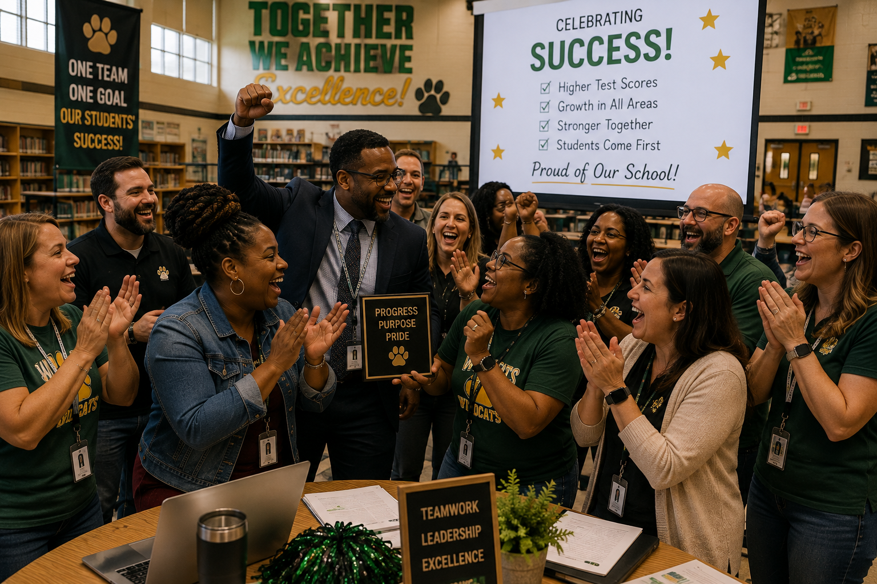

The Eatmon Edge builds capacity—not dependency

Professional Development Academy

Equipping Educators. Strengthening Instruction. Elevating Excellence.


Professional development should not simply give educators more information. It should change what happens when they return to the classroom.
1. Professional Development Academy Overview
The Eatmon Edge Professional Development Academy provides practical, research-informed professional learning experiences designed to strengthen educator capacity and improve student outcomes.
Our professional learning model moves beyond traditional sit-and-get workshops. Participants analyze, collaborate, practice, plan, reflect, and leave each session with strategies and resources they can immediately implement.
The Academy can provide learning experiences for:
- Classroom teachers
- Instructional coaches
- Department chairs
- Testing coordinators
- Counselors
- Assistant principals
- Principals
- District administrators
- Instructional leadership teams



2. The Eatmon Edge PD Philosophy

Professional learning should be:
Relevant — Connected to the educator's actual work.
Practical — Participants leave knowing what to do next.
Interactive — Educators should experience the strategies they are expected to use.
Data-Informed — School and student needs help determine the learning.
Collaborative — Educators learn with and from one another.
Reflective — Participants examine their current practices.
Sustainable — Learning continues after the workshop ends.

If professional development ends when the presentation ends, professional learning never really began.



3. The E.D.G.E. Professional Learning Model

E — EVALUATE
What do educators need?
The Eatmon Edge reviews available information such as school goals, student data, teacher surveys, observations and leadership priorities.

D — DESIGN
What learning experience will address the need/s?
Professional learning is customized rather than simply pulling out a presentation "off the shelf."

G — GROW
How will educators practice learning?
Participants collaborate, analyze examples, practice strategies, examine student work, and develop implementation plans.

E — EXCEL
How will we know the learning made a difference?
Follow-up examines implementation, educator feedback and, where appropriate, student outcomes.

Academy I — Data & Assessment

From Numbers to Next Steps
Turning Student Data into Instructional Action
Teachers learn how to move beyond simply reviewing assessment scores and determine what instructional response the data requires.
Participants practice:
Data analysis → Identifying trends → Determining causes → Planning response → Monitoring results

Formative Assessment That Actually Informs Instruction
Topics:
- Checks for understanding
- Exit tickets
- Questioning
- Student work analysis
- Feedback
- Reteaching
- Flexible grouping The Data-Driven PLC

Teachers learn a repeatable protocol for productive data meetings



ACT & College Readiness Academy

ACT Isn't Just an 11th-Grade Problem
This workshop helps educators understand how college-readiness skills can be developed across courses and grade levels.
Participants examine:
ACT domains, standards, question structures, prerequisite skills and opportunities for ACT-style reasoning within everyday instruction.

ACT Across the Curriculum
Not just math and English.
Sessions are developed for:
Mathematics
English
Reading
Science

Leading an ACT-Ready School
School leaders examine: Curriculum alignment → Student data → Teacher capacity → Intervention → Testing culture → Progress monitoring

Instructional Excellence Academy
This series serves teachers across content areas.
Possible sessions include:

Planning With Purpose
Standard → Learning Target → Success Criteria → Instruction → Assessment

Differentiation Teachers Can Actually Use

Engagement vs. Entertainment

Effective Questioning

Authentic Feedback That Moves Learning Forward

Student-Centered Instruction

Making Thinking Visible

Supporting Diverse Learners

From Compliance to Cognitive Engagement

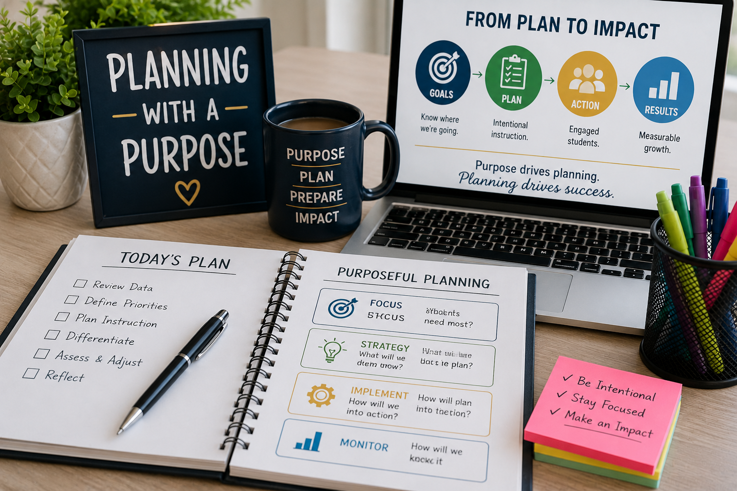

PLC & Collaborative Planning Academy

Session 1
What Should a PLC Actually Do?

Session 2
Planning From Standards

Session 3
Analyzing Student Work

Session 4
Using Common Assessment Data

Session 5
Planning Intervention and Enrichment

Session 6
Building Collective Teacher Responsibility

Instructional Leadership Academy
This Academy moves beyond teachers.
This is designed for principals, assistant principals, coaches and teacher leaders.
Possible sessions:

Leading Instruction, Not Just Managing Schools

What Leaders Should Look for in Classrooms

Giving Feedback That Improves Instruction

Leading Difficult Conversations

Building Teacher Capacity

Using Data Without Weaponizing Data

Creating a Culture of Continuous Improvement

Leading Effective PLCs

From School Improvement Plan to Classroom Practice

The central question:
Can teachers see the school's improvement priorities in what happens in classrooms every day?

Testing Coordinator Academy

From Testing Coordinator to Assessment Leader

Assessment Planning
Creating testing calendars and timelines.

Testing Logistics
Rooms, staffing, materials, and scheduling.

Training Test Administrators

Test Security

Accommodations

Testing-Day Operations

Make-Up Testing

Incident Documentation

Data Reporting

Post-Assessment Analysis
The focus wouldn't just be:
- "How do I administer the test?"
- It would also address:
- "How do I help my school use the results?"

New Teacher Academy

The Eatmon Edge New Teacher Institute
Possible sessions:
- Before Day One
- Classroom Culture
- Planning Effective Lessons
- Assessment
- Differentiation
- Student Engagement
- Parent Communication
- Professional Responsibilities
- Surviving Your First Semester
- Finishing the Year Strong



Curriculum Coach Academy
Possible sessions:

From Teacher to Coach

Coaching Without Evaluating

Building Teacher Trust

Conducting Productive Coaching Conversations

Facilitating Collaborative Planning

Using Data with Teachers

Observing Instruction

Giving Actionable Feedback

Measuring Coaching Impact

Developing Teacher Leaders



THE EATMON EDGE

Where Preparation Becomes Impact.
This binder is more than a collection of forms, protocols, and resources.
It represents a process for improvement—one that begins with understanding where we are, identifies where we need to go, and provides educators and leaders with practical tools to move forward with purpose.
Throughout The Eatmon Edge, one principle remains constant:
Data doesn't improve schools. What educators do because of the data improves schools.
The needs assessments help us listen.
The data protocols help us understand.
The planning tools help us prioritize.
The walkthroughs and coaching tools help us support.
The progress-monitoring tools help us adjust.
And the impact reports help us measure what has changed.
But the forms themselves are not the work.
The conversations are the work.
The decisions are the work.
The instruction is the work.
The follow-through is the work.
And student growth is the reason for the work.

The Eatmon Edge Commitment
We will not collect data simply to have it.
We will use information to ask better questions, make intentional decisions, strengthen instruction, support educators, and create better opportunities for students.
Because meaningful school improvement doesn't happen by accident.
It happens when we…
PREPARE with purpose.
PERFORM with intention.
SUCCEED through impact.

And when the binder closes...
The work begins.
THE EATMON EDGE
Turning Information into Instruction.
Turning Instruction into Impact.

Educate. Equip. Empower. Transform.

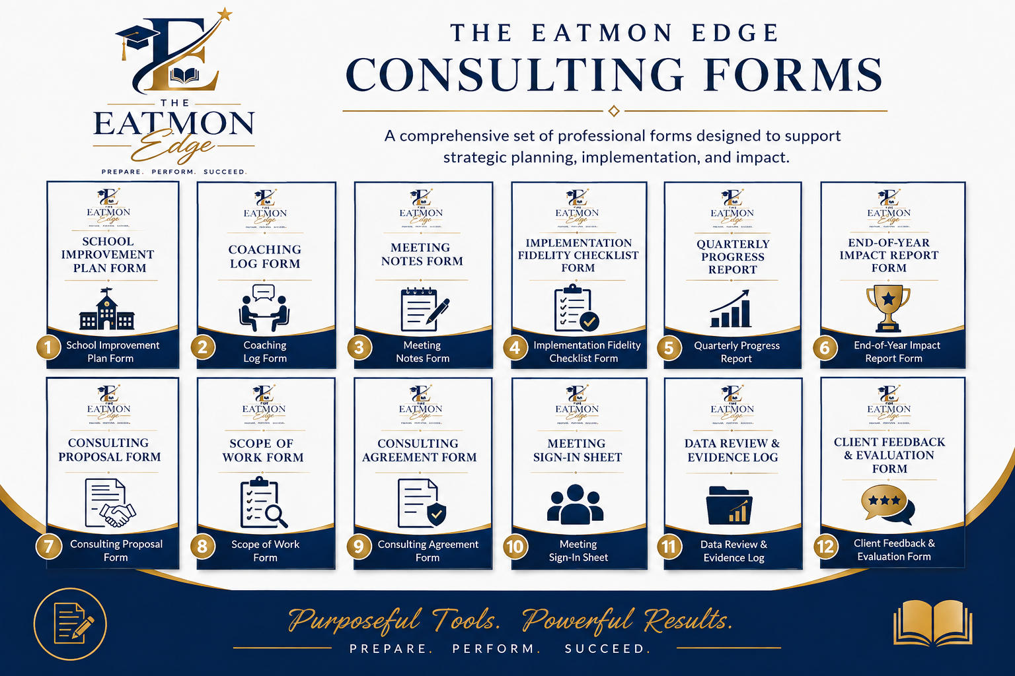
The Eatmon Edge helps schools make that connection.

